**PLUGGING INTO THE FUTURE: AN EXPLORATION OF ELECTRICITY CONSUMPTION PATTERNS**

**1. Introduction:**

Electricity consumption has been on the rise for decades with more and more people relying on electronic devices and appliances in their daily lives.It can increase green house gas emissions and environmental issues.

**Purpose:**

Electricity is a crucial resources that powers our homes,businesses and economies ,understanding how it is used is essential for developing sustainable and efficient energy systems**.**

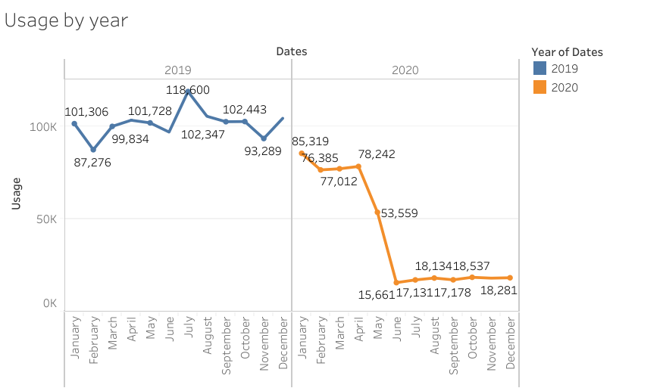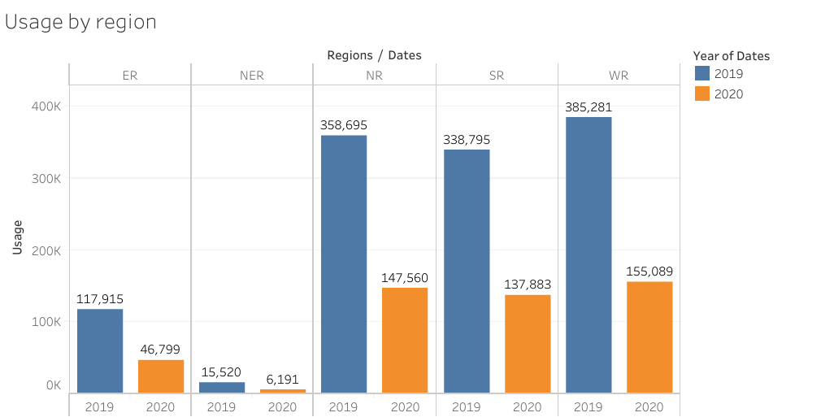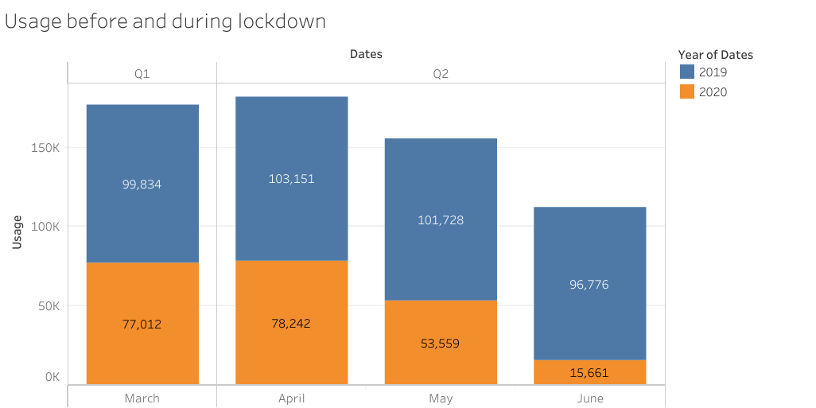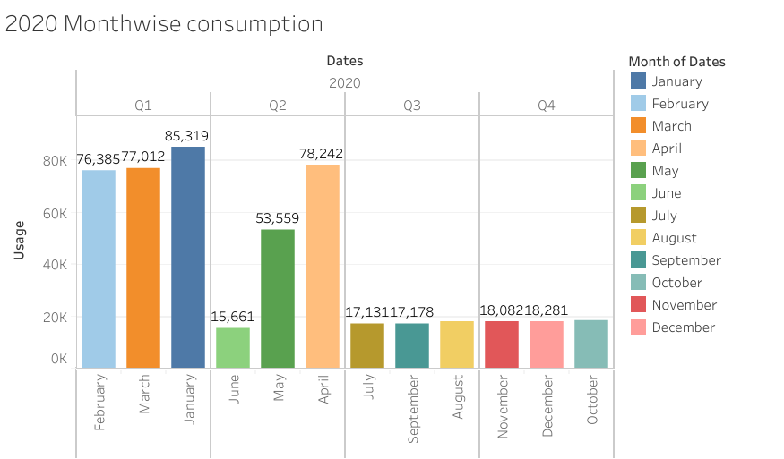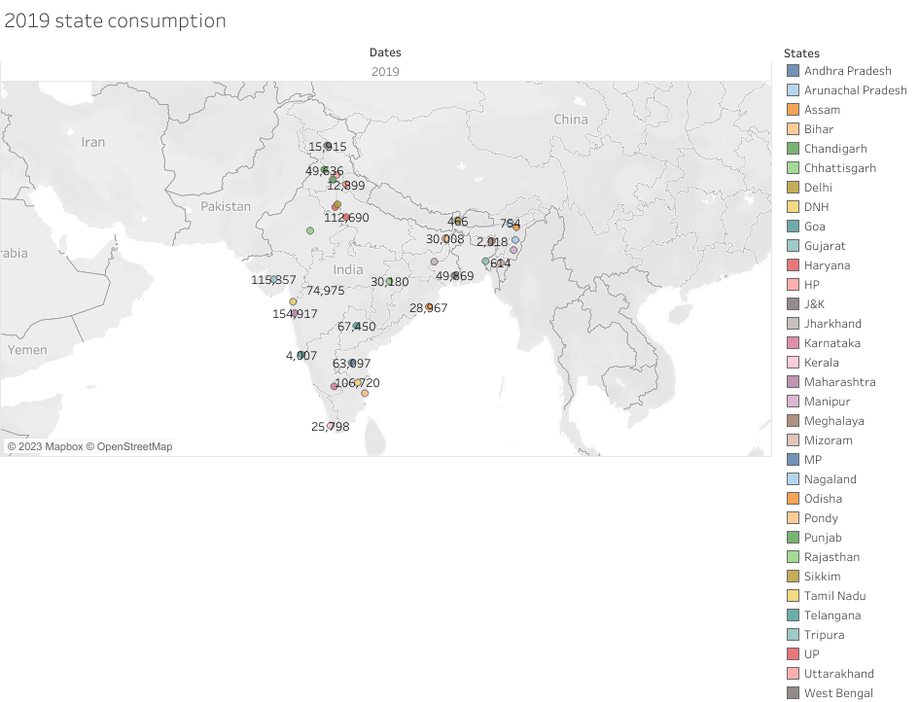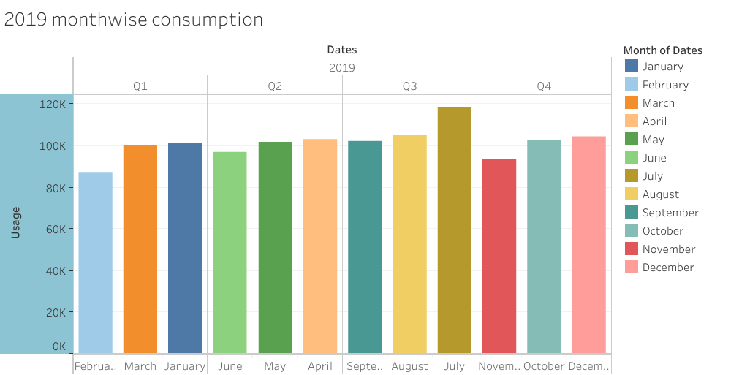

**4. Advantages:**

It is used to explore electricity consumption patterns and sustainable energy solutions can spur innovation and drive technological advancements in the energy sector

Improved energy efficiency and the adoption of renewable energy sources can lead to cost savings for households, business and government in the long run.

By examining electricity consumption patterns, we can increase awareness about the environmental impact of our energy consumption and help people make more informed choices about their energy use.

**Disadvantages:**

Electricity consumption patterns can be complex and difficult to understand, especially when complex and difficult to understand.

This can make it challenging to transition to renewable energy sources and reduce greenhouse gas emission.

This can also be costly.

**5. Applications:**

One important area of exploration is the integration of renewable energy sources. This trend is driven by the increasing availability of energy efficient and smart devices.

**6. Future scope:**

The integration of advanced digital technologies and sensors into the power grid can help improve efficiency and reliability, reduce energy waste. The growth of decentralized energy resources.

**7. Appendix:**

* International energy agency
* National Renewable energy
* U.S Energy information administration
* Smart electric power alliance
* Energy star